## Web Based Student Management System

Bulbul Ahmed Suborna Sutradhar, Masura Aktar, M M Tareq

Department of Computer Science & Engineering Bangladesh University of Business and Technology(BUBT)

Email: [mbbulbuli2@gmail.com](mailto:mbbulbuli2@gmail.com)

***Abstract*—** Student Management System provides a simple interface for maintenance of student information. It can be used by educational institutes or colleges to maintain the records of students easily. The creation and management of accurate, up-to-date information regarding a students’ academic career is critically important in the university as well as colleges. Student information system deals with all kind of student details, academic related reports, college details, course details, curriculum, batch details, placement details and other resource related details too. It tracks all the details of a student from the day one to the end of the course which can be used for all reporting purpose, tracking of attendance, progress in the course, completed semesters, years, coming semester year curriculum details, exam details, project or any other assignment details, final exam result and all these will be available through a secure, online interface embedded in the college’s website. It will also have faculty details, batch execution details, students’ details in all aspects, the various academic notifications to the staff and students updated by the college administration. It also facilitate us explore all the activities happening in the college, Different reports and Queries can be generated based on vast options related to students, batch, course, faculty, exams, semesters, certification and even for the entire college.

***Keywords—*** *Student Information System, Database, HTML, CSS, Php Laravel ,SQL*

1. **INTRODUCTION**

The design and implementation of a comprehensive student information system and user interface is to replace the current paper records [2]. College Staff are able to directly access all aspects of a student’s academic progress through a secure, online interface embedded in the college’s website. The system utilizes user authentication, displaying only information necessary for an individual’s duties[2]. Additionally, each sub-system has authentication allowing authorized users to create or update information in that subsystem. All data is thoroughly reviewed and validated on the server before actual record alteration occurs. In addition to a staff user interface, the system plans for student user interface, allowing users to access information and submit requests online thus reducing processing time. All data is stored securely on SQL servers managed by the college administrator and ensures highest possible level of security. The system features a complex logging system to track all users access and ensure conformity to data access guidelines and is expected to increase the efficiency of the college’s record management thereby decreasing the work hours needed to access and deliver student records to users. Previously, the college relied heavily on paper records for this initiative. While paper records are a traditional way of managing student data there are several drawbacks to this method. First, to convey information to the students it should be displayed on the notice board and the student has to visit the notice board to check that information. It takes a very long time to convey the information to the student. Paper records are difficult to manage and track. The physical exertion required to retrieve, alter, and re-file the paper records are all non-value added activities. This system provides a simple interface for the maintenance of student information. It can be used by educational institutes or colleges to maintain the records of students easily. Achieving this objective is difficult using a manual system as the information is scattered, can be redundant and collecting relevant information may be very time consuming. All these problems are solved using online student information management system. The paper focuses on presenting information in an easy and intelligible manner which provides facilities like online registration and profile creation of student’s thus reducing paper work and automating the record generation process in an educational institution.

**1.1 Problem Statement**

## A. The problem occurred before having computerized system includes -:

File lost when computerized system is not implemented , file is always lost because of human behaviour , due to some human error there may be a loss of records. File get damaged when a computerized system is not there, some cases like due to natural disasters , fire , floods etc. Difficulty to search record when there is no computerized system there is always difficulty in searching of records if the records are large in number. Space consuming , after the number of records become large the space for physical storage of file and records also increases.Without the computerized system it becomes very cost consuming as there is no computerized system to add each record , paper will be needed which will increase the cost management of library

**2.Literature Review**

There are numerous educational institutions in India. However, relatively few institutions are updated and employ software to handle their day-to-day operations. There are over 1000 schools in Bengaluru, as well as more than 300 pre-university colleges and degree colleges. Most of these academic institutions still rely on traditional management methods, which mostly involve paper work and a great deal of human labour, resulting in a great deal of stress and frantic work.[3]

Dhaka Varsity Student Management System (DU-SMS)[5]:

**Project Overview:**

The **Dhaka Varsity Student Management System (DU-SMS)** is a web application aimed at digitizing student data management for the **University of Dhaka**. It covers student enrollment, course registration, grading, and academic records, aligned with the structures of faculties and departments in DU.[5]

**3. Methodology**

This method is chosen because it is the most suitable method to be applied in this project development. The reasons or justifications for choosing the agile model (scrum) are it allows stakeholders to get involved more compared to other models. It promotes interaction between clients from system and developer. By involving clients from system in every phase of development, it improves the developer’s understanding of the client’s requirements. Student Management System for a school is an unfamiliar system compared to other Student Management System. Thus , communication among stakeholders is important for this project. Next, it allows changes throughout the period of development. It provides flexibility to both parties, the clients from system and the developer thus improve the client’s satisfaction. It also can handle uncertainties in requirements very well. It can adopt new or changing requirements and can be fixed throughout the period as clients from system are still uncertain about what they need and want from the system. It also makes the process of system development more practical and effective as it allows continuous delivery or release of useful software. It improves the quality of the system as in every iteration, all phases are conducted thus defects can be found and fixed quickly. Not only that, works are prioritized based on user stories, thus important functionalities or needs of the system will be developed first based on user requirements. By using this methodology, it is easier to track progress of the project to ensure that the project is delivered according to the planned schedules. To sum up, all requirements of the project are almost impossible to be identified correctly before other phases such as design and implementation happen. However, traditional methodology such as waterfall methodology assumes that such thing is possible. Thus, by adopting agile methodology in this project, changes can be made prior to clients‟ requirements and clients feedbacks that are received at every sprint or increment of the project.

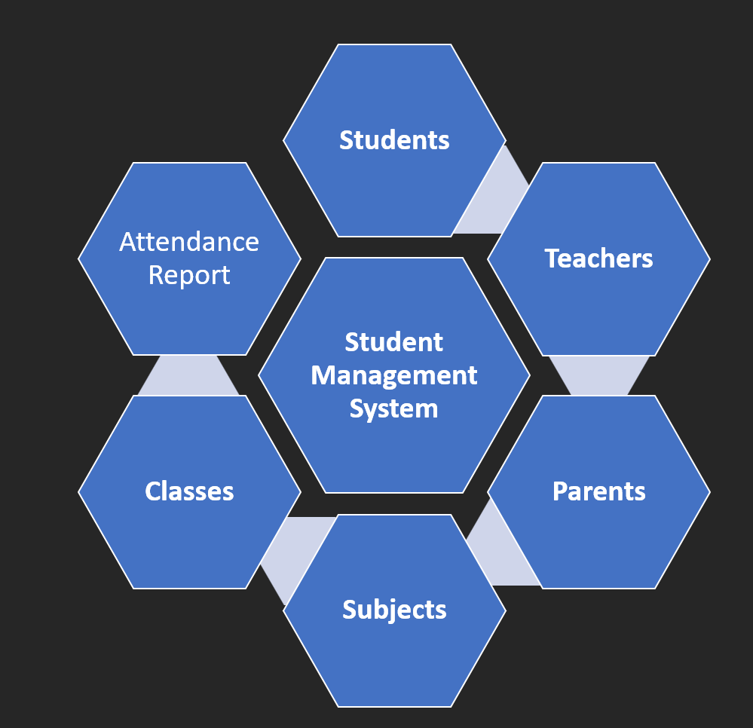

Fig:-ER Diagram

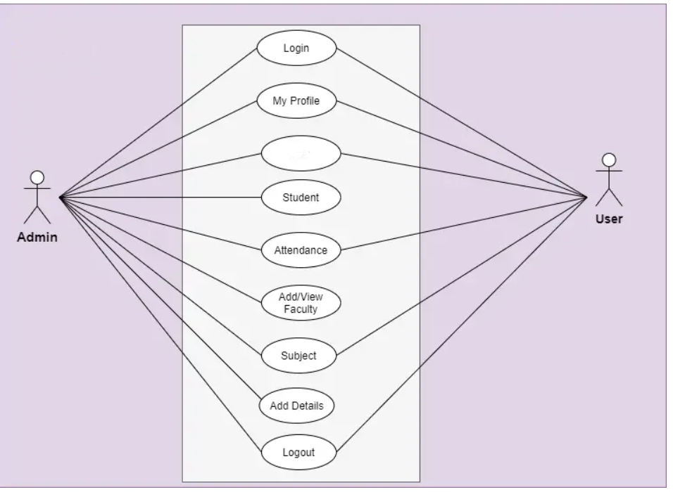

Fig:- DFD

## **4. Result Analysis**

This is our login page…

Here at first log in admin.

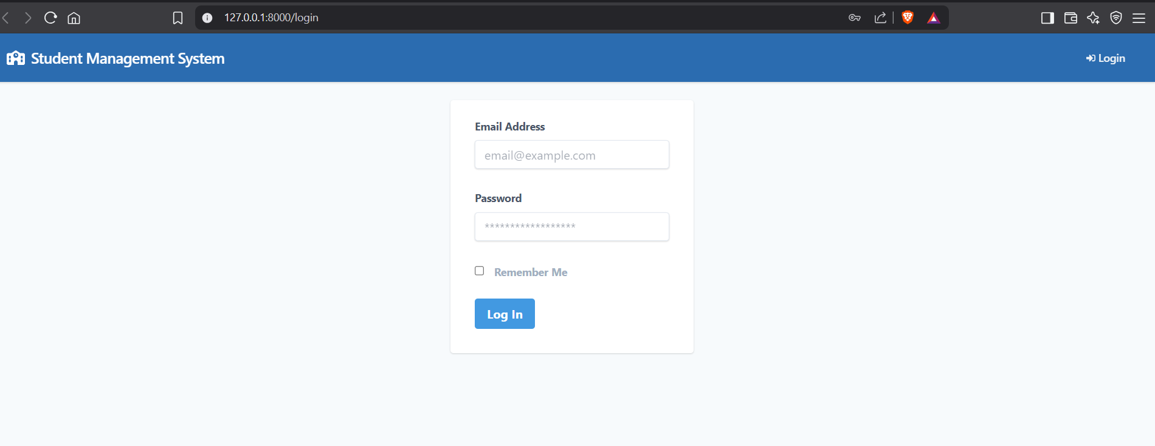.

After log-in this our dashboard,here we can see everything in a page.

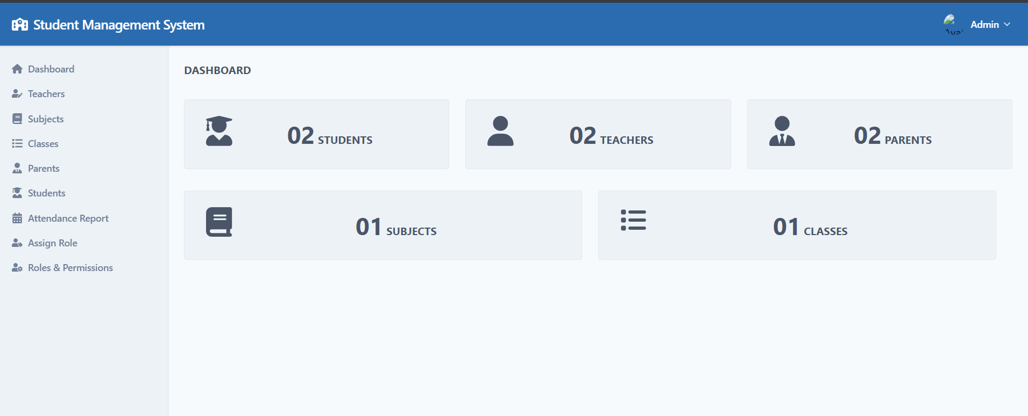

This is our Student panel :

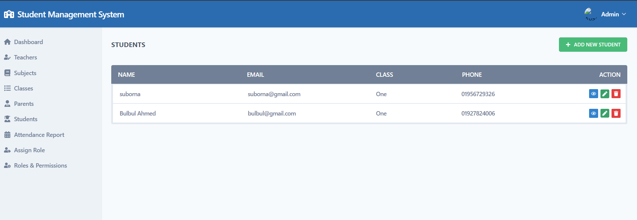

This is Parents Panel:

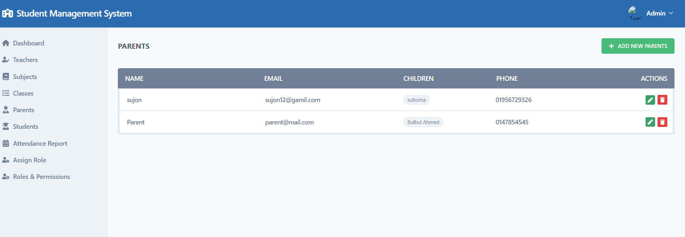

This is Teacher panel:

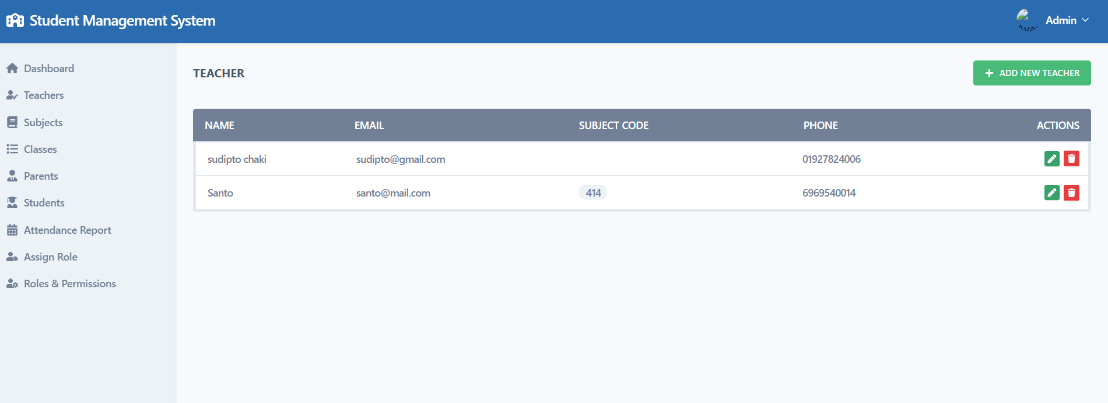

**It is subject part:**

**Here we add any subject detail.**

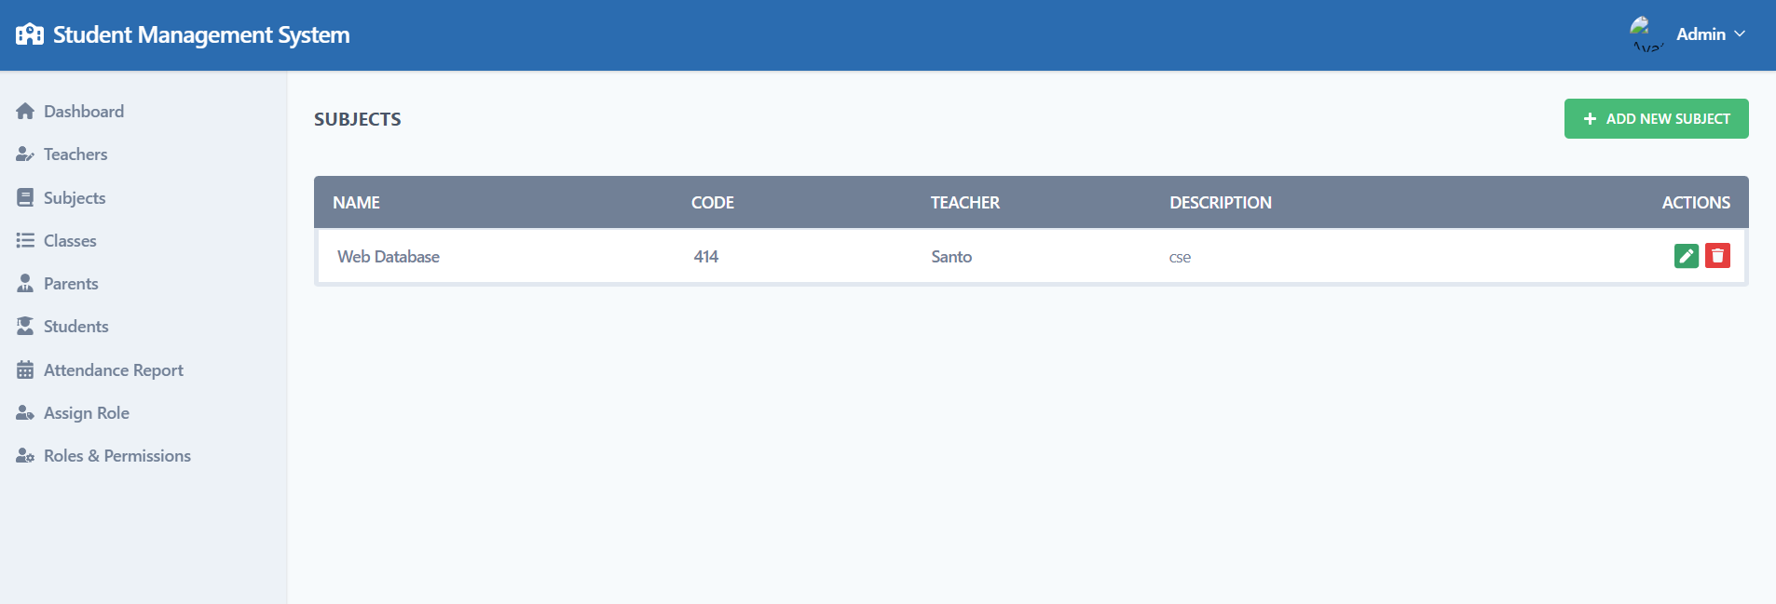

This is attendance report panel.

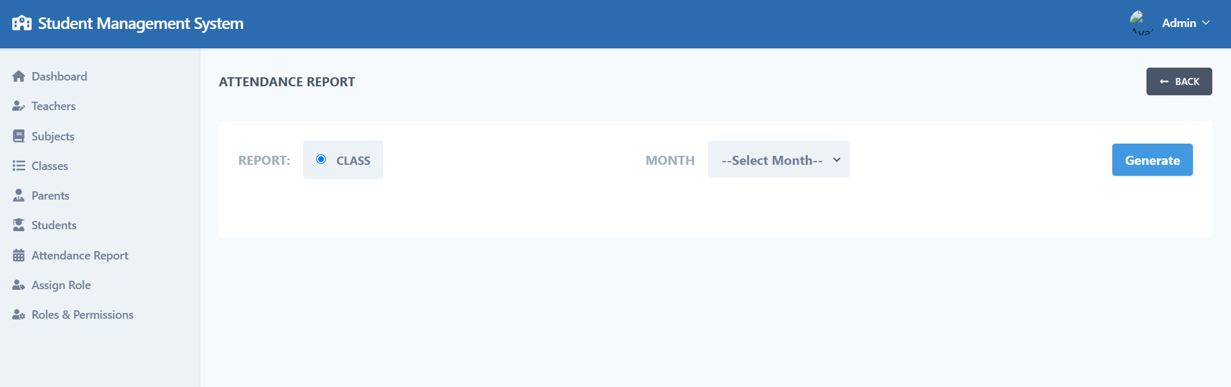

**5. Conclusions**

## It's usually a good idea to go with a student information system that's built on a current system architecture to keep up with changing needs. This system should include wellorganized data coding and clearly defined business applications. The system's overview elucidates the convenience of exact data delivery at the tip of your fingertips, increasing student retention and teaching them how to manage their time effectively. The proposed method is efficient and user-friendly, based on the results of the experiments and tests. In comparison to current methods of managing academic institutions, this project, which produces centralised software, makes work administration and management easier and gives full information about the issue of users' interest with just one mouse click. An easy-to-use user interface centralised software can be offered to the educational institution, allowing all services linked with the university to interact with one another and share data. The user will be able to access the resources from afar because this is a ReST API . Because the application is built with a microservice architecture and agile methodology, services can be added in the future

*Advantages of the application -:*

For administration

• Teachers, professors, and staff can prepare result analysis reports using the student result management system. Provide a single point of contact for the compilation of all internal examination reports. Obtain quick prints of examination and test reports. In no time, you'll be able to calculate scores, percentages, and grades. In addition, the workload will be much reduced

## For Students

## Download a PDF version of the findings report. Students can now access their grades via any internet platform. There is no need to go to college or school physically. With a valid Roll number/ID, you can look up test and exam results. Re-evaluation is requested. Students can request a re-evaluation online with no additional requirements.

## Disadvantages of the application -:

## Hackers are prone to gaining access to the student result management system. After the deadline, the administration is unable to update or modify scores. Because data is stored in the database. The application's extensive modules and features make it tough for a user to use it. . Minor glitches or bugs can turn application crashed. Heavy traffic on application can cause problem for web application.

*4.1 Future Scope*

The project's future potential is enormous. In the future, the project could be deployed on an intranet. Because it is quite versatile in terms of expansion, the project can be upgraded in the near future as and when the need arises. The customer may now manage and thus run the complete task in a lot better, accurate, and error-free manner now that the planned database Space Manager software is ready and fully functional. The following is the project's future scope. In the future students may also be able to post or download notes in the future. There will be a few little modifications here and there to make the app more visually appealing, as well as statistics, tracking, and analytics. For significantly more, the entire project will be made available as an Android app. Artificial intelligence's contribution to several fields is growing all the time. So in the future we will be using some machine learning algorithms in application, to make it more efficien.

### **6.ACKNOWLEDGMENT**

I would like to express my sincere gratitude to everyone who supported me throughout the development of this **Student Management System** project.

I really grateful and wish my profound my indebtedness to Supervisor Sadah Anjum Shanto., Associate Professor, Department of CSE

First and foremost, I am extremely grateful to my respected teacher, Sadah Anjum Shanto, for their valuable guidance, constructive feedback, and encouragement at every stage of this project. Their expertise and insight greatly helped shape the direction and quality of my work.

I would also like to thank the **Department of CSE**, **Bangladesh University of Business and Technology**, for providing the opportunity and resources to carry out this project.

Special thanks to my classmates and friends who offered ideas, shared knowledge, and helped test the system during development.

Finally, I extend my deepest appreciation to my family for their constant support and motivation.

This project has been a great learning experience, and I am truly thankful to everyone who contributed directly or indirectly to its successful completion.

**Bulbul Ahmed**  
**21225103242**  
**26/5/2025**

### **7.REFERENCES**

[1]<https://bubt.edu.bd/>

[2]https://www.wikipedia.org/

[3] Zhibing Liu, Huixia Wang,Hui Zan “Design and implementation of student information management system.” 2010 International symposium on intelligence information processing and trusted computing. 978-0-7695- 4196-9/10 IEEE.

[4]Application development using <https://angular.io/docs>

[5]https://www.du.ac.bd/